EE5630 DSP f2020 HW# 2 (ch.3) Due 15:30, 11/22/2020

1. (10%)

Using any method, determine the inverse z-transform or *x*[*n*] for each of the following:

1. ,
2. 
3. 
4. 
5. 

2. (10%)

A causal LTI system has the system function:



(a) Write down the difference equation that is satisfied by the input and output of the system.

(b) Plot the pole-zero diagram and indicate the ROC for the system function.

(c) Determine the output of the system when the input is *x*[*n*] = *u*[*n*].

(d) Determine the input *x*[*n*] so that the corresponding output is *y*[*n*] = [*n*]-[*n*-1].

(e) Determine the output *y*[*n*] when the input is *x*[*n*] = cos(0.5*n*).

3. (10%)

Consider the following difference equation:



Use *z*-transform to answer the following questions:

1. Both a causal and an anticausal LTI system are characterized by this difference equation. Find the impulse responses of the two systems.
2. Determine the stabilities of the causal LTI system and the anticausal LTI system.
3. Determine the unique solution to the difference equation when *x*[*n*] = (1/2)*nu*[*n*] and *y*[-1] = 0, *y*[-2] = -12.
4. If the difference equation represents an LTI system, determine the zero-state response of the system to the input . What is the steady-state response of the system?

4. (10%)

When the input to an LTI system is

,

the output is

.

1. Find the system function *H*(*z*) of the system. Plot the poles and zeros of *H*(*z*), and indicate the ROC of *H*(*z*).
2. What are the ROCs of *X*(*z*) and *Y*(*z*)?
3. Find the impulse response *h*[*n*] of the system.
4. Write the difference equation that characterizes the system.
5. Is the system stable? Is it causal?

5. (10%)

The following information is known about an LTI system:

(i) The system is causal.

(ii) When the input is 

the z-transform of the output is 

**(a)** Find the z-transform of *x*[*n*]*.*

**(b)** What are the possible choices for the ROC of *Y*(*z*)*?*

(c) What are the possible choices for a linear constant -coefficient difference equation used to describe the system?

**(d)** What are the possible choices for the impulse response of the system?

6. (10%)

When the input to an LTI system is 

the output is 

(a) Find the system function *H*(*z*)of the system. Plot the poles and zeros of *H*(*z*)*,* and indicate the ROC.

(b) Find the impulse response *h*[*n*]of the system.

(c) Write the difference equation that characterizes the system.

(d) Is the system stable? Is it causal?

7. (10%)

A system with input *x*[*n*] and output *y*[*n*] is represented by the following block diagram, where *h*[*n*] is the impulse response of the LTI system within the inner box and its *z*-transform, *H*(*z*), exists with the following ROC:

0 <*rmin*< |*z*| <*rmax*<∞.

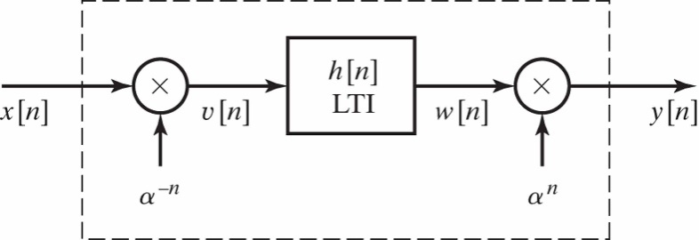

1. Can the LTI system with impulse response *h*[*n*] be bounded input bounded output stable? If so, determine inequality constraints on *rmin* and *rmax* such that it is stable. If not, briefly explain.
2. Is the overall system LTI? If so, find its impulse response *g*[*n*]. If not, briefly explain why.
3. Can the overall system be BIO stable? If so, determine inequality constraints relating **, *rmin* and *rmax* such that it is stable. If not, briefly explain.

8. (10%)

A causal and stable LTI system S has its input *x*[*n*] and output *y*[*n*] related by the linear constant-coefficient difference equation



Let the impulse response of S be the sequence *h*[*n*].

1. Show that *h*[0] must be nonzero.
2. Show that 1 can be determined from knowledge of , *h*[0], and *h*[1].
3. If *h*[*n*] = (0.9)*n*cos(*n*/4) for 0≦*n*≦10, sketch the pole-zero plot for the system function of S and indicate the ROC.

9. (10%)

The signal *y*[*n*] is the output of an LTI system with impulse response *h*[*n*] for a given input *x*[*n*]. Throughout the problem, assume that *y*[*n*] is stable and has a *z*-transform *Y*(*z*) with pole-zero plot shown below (left). Also shown (right) is the pole-zero plot of *X*(*z*),the *z*-transform of *x*[*n*], which is stable, too.

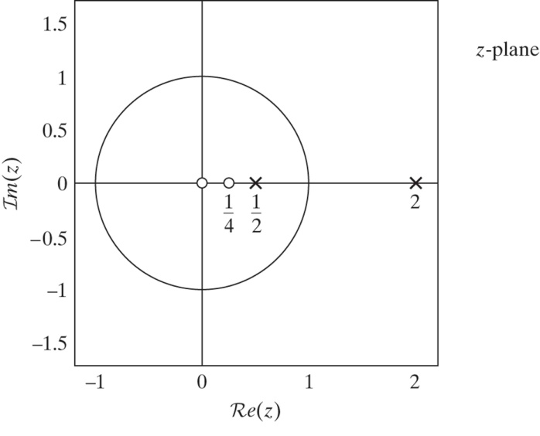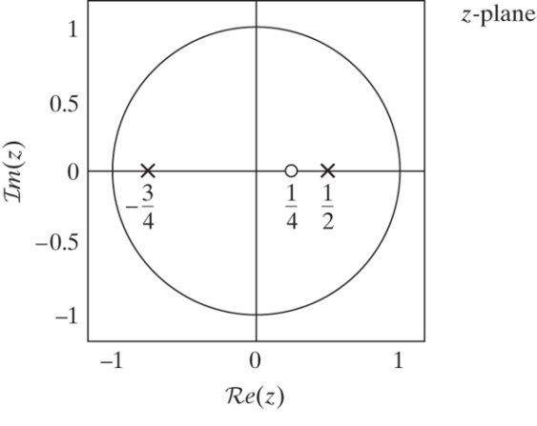

1. What is the ROC of *Y*(*z*)? Is *y*[*n*] left-sided, right-sided, or two-sided?
2. What is the ROC of *X*(*z*)? Is *x*[*n*] causal?
3. What is *x*[0]?
4. Draw the pole-zero plot of *H*(*z*) and specify its ROC.
5. Is *h*[*n*] anticausal?

10. (10%)

**In** Figure below, *H*(*z*)is the system function of a causal LTI system.

1. Using z-transforms of the signals shown in the figure, obtain an expression for *W*(*z*)in the form *W*(*z*) = *H*1(*z*) *X*(*z*)+ *H*2(*z*) *E*(*z*) where both *H*1(*z*)and *H*2(*z*)are expressed in terms of *H*(*z*)*.*

**(b)** For the special case *H*(*z*)= *z*-1/(1- *z*-1), determine *H*1(*z*)and *H*2(*z*)*.*

**(c)** Is the system *H*(*z*)stable? Are the systems *H*1(*z*)and *H*2(*z*)stable?

